CO1 EXPERIMENT 06(a)
Title

Simulation and Performance
Evaluation of People–Process–Data–Things IoE Framework using Edge/Fog-to-Cloud
Pipeline

Objectives
- Define the packet size as 1500 bytes and generate data rates from 0.5 to 20 Mbps.
- Calculate the transmission delay using the standard formula.
- Define the propagation, processing, and queueing delays for Edge, Fog, and Cloud.
- Calculate the total end-to-end delay for each framework.
- Plot the delay against the data rate using a line graph and compare the results.

Program code
import numpy as np
import matplotlib.pyplot as plt

# Simulation parameters
packet_size = 1500 * 8 # 1500 bytes converted to bits

# Data rate in Mbps
data_rate = np.linspace(0.5, 20, 100)

# Standard transmission delay formula
# Delay (ms) = Packet size (bits) / Data rate (bits/s) * 1000

transmission_delay = packet_size / (data_rate * 1e6) * 1000

# Illustrative fixed delay components in milliseconds
# These values are assumptions for simulation, not universal constants
data_source=450

# Edge
edge_propagation = 1*data_source
edge_processing = 2*data_source
edge_queueing = 0.5*data_source

# Fog
fog_propagation = 5*data_source
fog_processing = 4*data_source
fog_queueing = 1.5*data_source

# Cloud
cloud_propagation = 20*data_source
cloud_processing = 8*data_source
cloud_queueing = 3*data_source

# Total end-to-end delay
edge_delay = (
transmission_delay + edge_propagation
+ edge_processing + edge_queueing
)
print(edge_delay[50])

fog_delay = (
transmission_delay + fog_propagation
+ fog_processing + fog_queueing
)
print(fog_delay[50])

cloud_delay = (
transmission_delay + cloud_propagation
+ cloud_processing + cloud_queueing
)
print(cloud_delay[50])
# Plot results
plt.figure(figsize=(9, 5))

plt.plot(data_rate, edge_delay, label="Edge")
plt.plot(data_rate, fog_delay, label="Fog")
plt.plot(data_rate, cloud_delay, label="Cloud")

plt.xlabel("Data Rate (Mbps)")
plt.ylabel("End-to-End Time Delay (ms)")
plt.title("IoE Framework: Time Delay vs Data Rate")

plt.grid(True)
plt.legend()
plt.tight_layout()
plt.show()

output

Technology |  | No of data source | No of data source | No of data source | No of data source
 |  | 1ms | 120ms | 175ms | 235ms
Edge | Processing_delay | 1 | 120 | 175 | 235
 | Propogation_delay | 2 | 240 | 350 | 470
 | Queing delay | 0.5 | 60 | 87.5 | 117.5
 | End to end delay | 4.65 | 421.13 | 613.65 | 613.659
fog | Processing_delay | 5 | 600 | 875 | 1175
 | Propogation_delay | 4 | 480 | 700 | 940
 | Queing delay | 1.5 | 180 | 262.5 | 352.5
 | End to end delay | 11.65 | 1261.15 | 1838.659 | 1838.659
cloud | Processing_delay | 20 | 2400 | 3500 | 4700
 | Propogation_delay | 8 | 960 | 1400 | 1880
 | Queing delay | 3 | 360 | 525 | 705
 | End to end delay | 32.15 | 3721.15 | 5426.159 | 5426.159

1
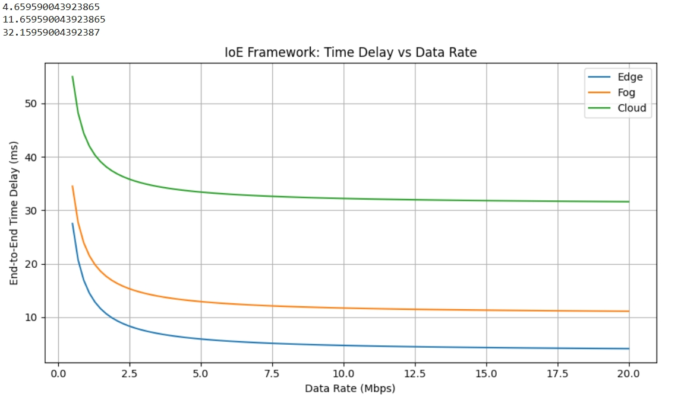
175
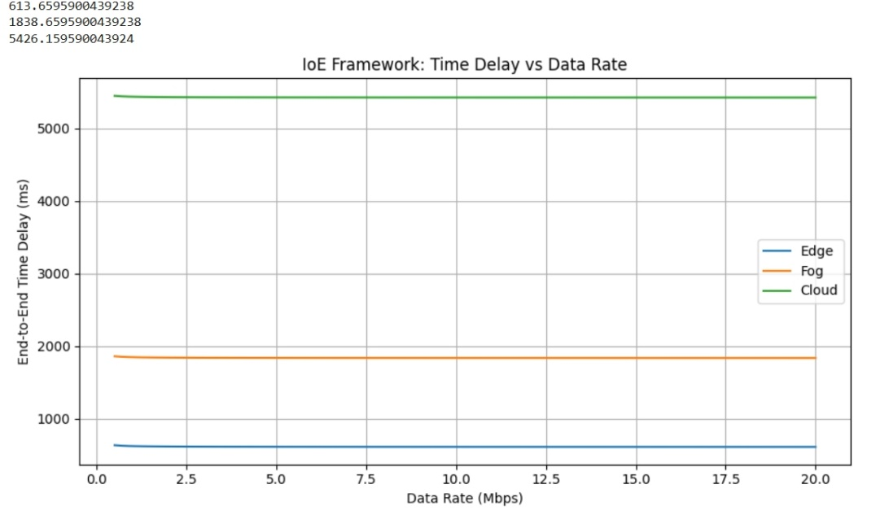

120

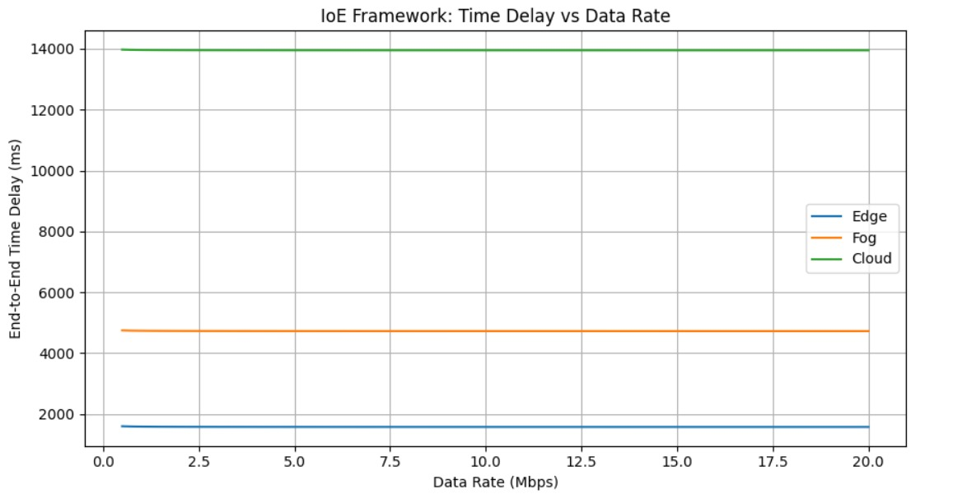

235
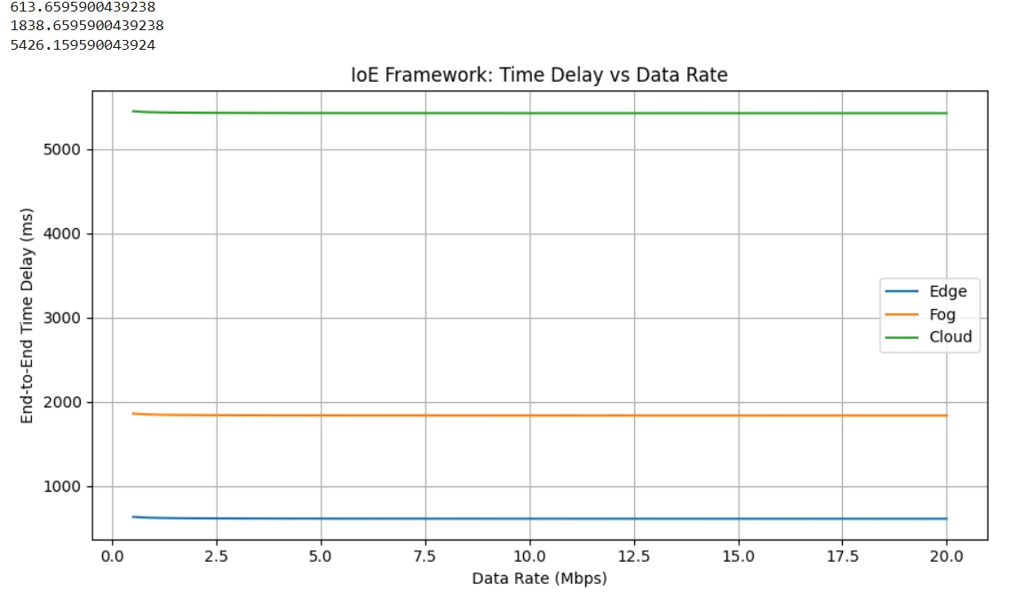

Result
The end-to-end time delay for Edge, Fog, and Cloud computing was simulated and plotted successfully. The graph shows that transmission delay decreases as the data rate increases. Based on the assumed delay values, Edge computing has the lowest delay, followed by Fog and Cloud computing.

